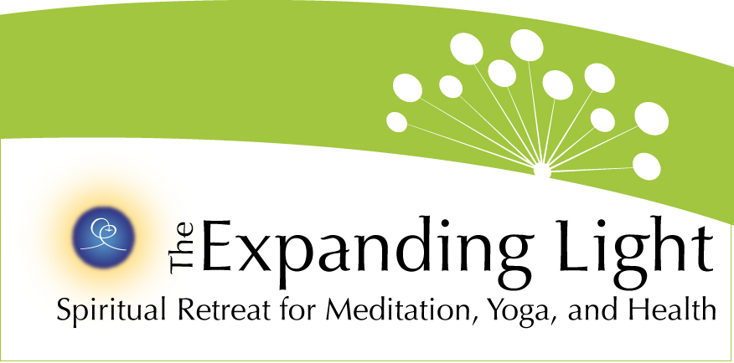

FOR IMMEDIATE RELEASE

CONTACT: Robert Yehling (917) 826-7880 • bob@wordjourneys.com
Gary Evans • garyje@hotmail.com
The Expanding Light: (800) 346-5350

http://www.theyugasconference.com

GROUND BREAKING EVENT, THE YUGA CYCLES CONFERENCE,
TAKES PLACE MAY 25-28 IN NEVADA CITY, CA

ANANDA VILLAGE, NEVADA CITY, CA (March 22) – The Yuga Cycles of the Ages & Our Awakening Consciousness, a weekend of findings, presentations and discussions on ways the Yugas cyclical measurement of time has directly impacted the history of mankind, will take place May 25-28 and be hosted by The Expanding Light at Ananda Village, near Nevada City.
The conference, held in partnership with Ananda College of Living Wisdom, will bring together eminent scientists, educators, psychologists, geologists, yoga practitioners and spiritual leaders from around the world. They will address how the ancient wisdom of the Yugas and consequent discoveries relate to today’s acceleration of energy, technology and inner and outer understanding in fields, professions and individual lives. The yugas (or ages) are part of a 24,000-year cycle of the development of human civilization and human awareness, and are correlated in 200 mythic tales, found across 40 ancient cultures.
Speakers include bestselling author Joan Borysenko, Amit Goswami (featured in What The Bleep Do We Know), Ananda founder Swami Kriyananda (author of 130 books), The Yugas co-authors David Steinmetz and conference emcee Joseph Selbie, Boston University geology professor Dr. Robert Schoch, Claude Swanson, Christopher Dunn, Uma Krishnamurthy and Walter Cruttenden, author of Lost Star of Myth and Time.
Registration for the event is continuing. Seating and accommodations are strictly limited to 180 people on a first-come, first-served basis. For more information on registration, go to http://www.theyugasconference.com or call 800-346-5350.

FOR IMMEDIATE RELEASE

CONTACT: Robert Yehling (917) 826-7880 • bob@wordjourneys.com
Gary Evans • garyje@hotmail.com
The Expanding Light • (800) 346-5350

http://www.theyugasconference.com

ANANDA VILLAGE AND EXPANDING LIGHT’S DWAPARA YUGA WAY OF LIVING FEATURED AT YUGA CYCLES CONFERENCE MAY 25-28

ANANDA VILLAGE, NEVADA CITY, CA (March 22) – The focus of the upcoming Yuga Cycles of the Ages & Our Awakening Consciousness Conference at The Expanding Light will be on how past civilizations and cultures can inform our spiritual, technological and energetic acceleration today, and where that will take us in the future.
Participants who arrive at The Expanding Light and Ananda Village, the host location for the Yuga Cycles Conference Memorial Day Weekend, May 25-28, will find out that the future is now — and that the residents of Ananda Village have practiced heightened principles of the current age, Dwapara Yuga, for many years.
There couldn’t be a better place!” says conference director Timothy Hickey of The Expanding Light. “We are part of Ananda Village, a dynamic example of living a life dedicated to awakening consciousness. For our part, we literally serve every day of the year supporting the personal growth of individuals on their path – in the deepest sense.”
Registration is continuing on a first-come, first-served basis for the Yuga Cycles Conference, which has exclusive, limited seating. For more information on registration, go to http://www.theyugasconference.com or call 800-346-5350.
Expanding Light and Ananda Village promotes a lifestyle that brings out the most advanced ways of communication, business, education, sustainable living, creative expression, cooking and nutrition, whole body-mind-spirit health, and supporting the spiritual growth of all visitors and residents, from all paths, through the scientific practice of yoga and meditation. It reflects the highest tenet of Dwapara Yuga: complete integration of the inner and outer person. All of this is set on 800 majestic acres in the Sierra Nevada foothills, while guests enjoy The Expanding Light’s comfortable guest facilities and fine vegetarian cuisine.
The Expanding Light’s busy schedule — more than 120 programs per year — reflects these principles and shares them in an engaging, inviting way that retreat guests find very easy to take home and integrate immediately into their lives. Attendees at the Yuga Cycles Conference will experience and participate in this Dwapara Yuga approach throughout the Memorial Day weekend.
“Guests come here from all over the world to refresh and renew – and leave feeling energized and uplifted,” Hickey says. “They participate not just in classes and professional trainings where we share the ancient yogic practices of meditation, proper diet, hatha yoga, right thinking and balanced living, but they also live in the energy of the retreat where we have been meditating and doing yoga for more than 40 years.
“This is Dwapara energy, a palpable energy field that is supportive for each individual guest to soak in new techniques and teachings and develop a plan to make very positive life changes where ever they return to,” he added.
Dwapara Yuga, the age of increasing energy and consciousness, is one of the four cycles, or Yugas, that constitutes a “Great Year”, or a 24,000-year cycle. Each Yuga is marked by corresponding increases or decreases in spiritual and physical energy. Over 200 hundred mythic tales, found across 40 ancient cultures, include the lore of higher ages in the past. In the west, we know them as the Greek Golden Age, Silver Age, Bronze Age and Iron Age. In India, they are called Satya, Treta, Dwapara and Kali Yuga.
These cycles and their impacts on the past, present and future of mankind will be discussed by an esteemed group of 10 internationally known speakers that includes:
• Author and mind-body medicine pioneer Joan Borysenko;
• Quantum physicist Amit Goswami, featured in What The Bleep Do We Know;
• Ananda community founder Swami Kriyananda, author of more than 130 books;
• Scientist-educator David Steinmetz, co-author of The Yugas;
• Geologist/professor Dr. Robert Schoch, who re-dated the Great Sphinx’s age by thousands of years;
• Christopher Dunn, best known for his book, The Giza Power Plant;
• Claude Swanson, an expert on the scientific evidence for the presence of a discernible life force;
• Uma Krishnamurthy, practitioner and presenter of the ancient/modern synthesis called Yoga Psychology;
• Walter Cruttenden, producer of the successful CPAK Conference and The Great Year DVD, and author of Lost Star of Myth and Time;
• Conference emcee Joseph Selbie, co-author of The Yugas
“Participants can expect a fascinating series of presentations – together forming a powerful look into how the cycles of time really operate,” Hickey said. “They can go deeply into current understanding of ever-fascinating topics like the dawn of time, pyramids, quantum physics and higher consciousness, body-mind health, the Great Sphinx, what the Universe is made of, yoga psychology and spirituality in this Age. All of this delivered by serious students of reality in the various fields of study.”
The Expanding Light Retreat, site of the conference and accommodations, is located in Ananda Village, approximately 75 miles northeast of Sacramento in the Sierra Nevada foothills. The non-profit retreat is open year-round and offers 120 programs in holistic health, meditation, and spiritual living. The retreat features various accommodation options, a professional vegetarian kitchen, and Center for Radiant Health, all within Ananda Village, an 800-acre intentional spiritual community.
Event partner Ananda College of Living Wisdom is the only college in the United States, and perhaps the world, that offers advanced curriculum in the Yuga Cycles and Awakening Consciousness. The college features a standard curriculum plus four-year programs in Inspirational Arts, Yoga Philosophy and Sustainability, and certificate programs in Yoga Teacher Training and Education for Life. Faculty and board members include Yuga Cycles Conference presenters Swami Kriyananda, Amit Goswami, Walter Cruttenden and Joseph Selbie, along with Robert Schoch, who will deliver the commencement address for the Class of 2012. Founded in 2003, Ananda College is located five miles from Ananda Village. A second campus will open in September, 2012 near Portland, Ore.
For more information on registration, go to http://www.theyugasconference.com or call 800-346-5350.

